Worksheet 7.1

Nature’s time machine
Student: Class:

Secrets in the ice
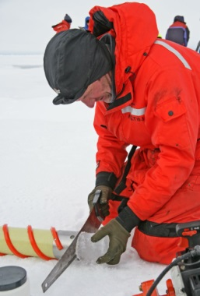
Scientists may not have discovered a time machine yet, but they do have a way of looking back over 300 000 years by looking at ice cores. Scientists drill into the ice of Antarctica and collect samples from deep down. Ice cores provide information about the Earth and the atmosphere over hundreds of thousands of years.
For thousands of years, snow has fallen in Antarctica. The snow turns to ice, which builds up over time. Dust, gases and other substances from the air become trapped in the ice. The trapped substances provide information about what was in the air at the time the snow fell.
By studying dust in the ice cores, scientists can work out when certain volcanoes have erupted. They have linked radioactive substances in the ice to nuclear disasters in various parts of the world. The dust and radioactive substances were probably carried to Antarctica by the wind.
Scientists have used ice cores to track the amount of carbon dioxide in the air and the Earth’s temperature. The graphs on this page show how these have changed over the past 400 000 years.

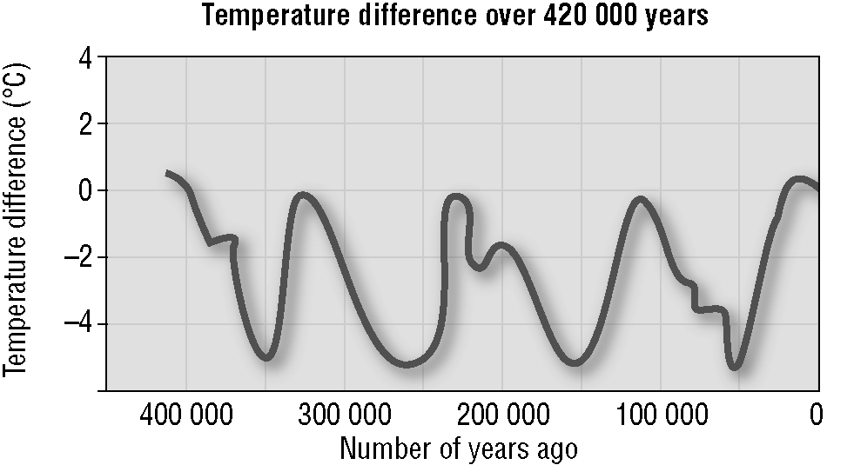
Zero on the temperature scale represents the Earth’s average temperature now. On the temperature line, the peaks represent warmer periods of time. In between the peaks, the average air temperature was up to 6°C lower than now. These colder times are called the ice ages.
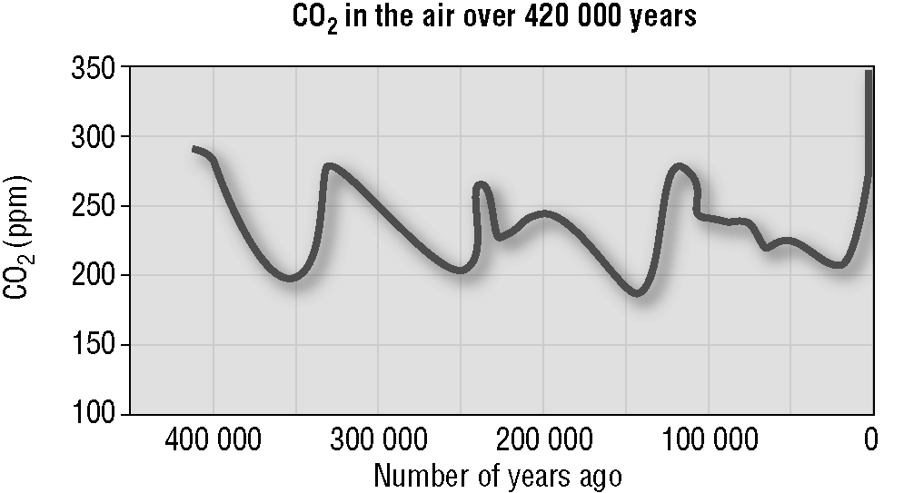
The line for carbon dioxide resembles the temperature line. When the temperature was higher, there was more carbon dioxide in the air. When the temperature dropped, so did the amount of carbon dioxide. (ppm means parts per million.)

Look at the graphs above of how carbon dioxide and temperature have changed over time and answer the following questions.
This ice core was drilled from more than 3.7 km down. Parts of it are more than 150 000 years old. Photo: Public domain
1. How many ice ages have there been in the past 400 000 years?
2. At a point 350 000 years ago:
(a) how much carbon dioxide was in the air
(b) how much colder was the Earth’s air compared to the present temperature?
3. Has the Earth ever been warmer than it is now? If so, how much warmer?

4. When was the amount of carbon dioxide in the air the highest?

Worksheet 7.1

Page 2

5. Why is an ice core like a time machine?

Recycling carbon
Carbon atoms are found in the air, soil, rocks, oil and gas below the Earth’s surface, and all living things. The number of carbon atoms on Earth always remains the same. When living things use carbon atoms, the atoms don’t just disappear; they are recycled. The diagram below shows the recycling of carbon. It also shows how humans have added to the amount of carbon dioxide in the air. We must take care not to interfere with the natural recycling process.
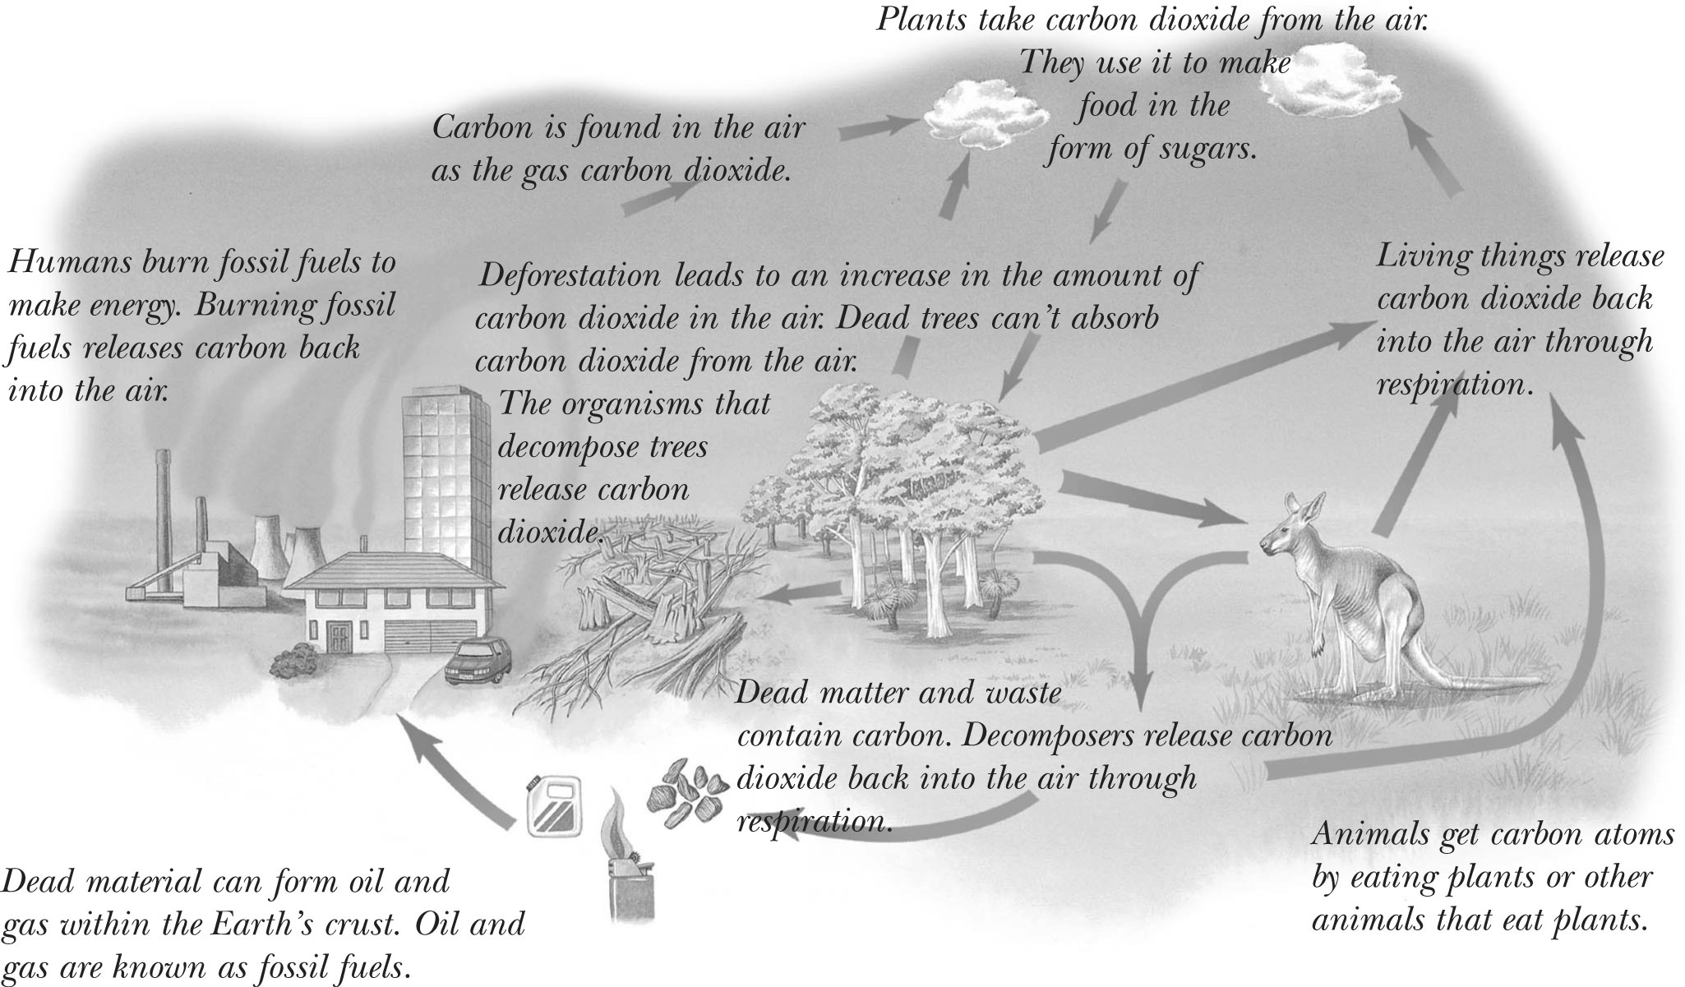
1. How do animals get carbon as part of the carbon cycle?

2. Explain two ways in which carbon that is contained within a plant can end up back in the air.

3. Where in the carbon cycle is carbon stored for long periods of time?

4. Would the carbon cycle still take place if humans did not exist? Explain.

5. How do humans add extra carbon dioxide to the air?

